Stationarity and Time Series Visualizations best practices
Fares Ahmed
- Stationarity
  - Why Stationarity Matters
- Most classical models (AR, ARMA, ARIMA, SARIMA) assume stationarity.
- A non-stationary series can produce spurious correlations and unstable coefficients.
- Stationarity ensures that past patterns are predictive of future patterns.
  - How Practitioners test for Stationarity
- Visual check: Plot the series, rolling mean, and rolling standard deviation.
- Statistical tests:
- Augmented Dickey–Fuller (ADF)
- KPSS test (null = stationary)
- Phillips–Perron
- ACF/PACF plots to check for decay in autocorrelations.
  - How They fix Non-Stationarity
- Differencing (first, seasonal, or higher order).
- Log / sqrt transformations to stabilize variance.
- Detrending or removing seasonality.
- Using models that handle non-stationarity directly (Prophet, state-space models, machine learning).

  - Real-World Examples (with sources)
Sector | Visual Type | Why it Works better
  Finance
  Hyndman & Athanasopoulos (2018), Forecasting: Principles and Practice
  Non-stationary stock price data was differenced before ARIMA modeling.
  Energy demand forecasting
  “Short-Term Electricity Load Forecasting” (IEEE 2017)
  Seasonal differencing applied to make load stationary before SARIMA.
  Climate
  NOAA time series analysis blog
  Used KPSS + differencing to remove seasonal trend before fitting AR models.

- Visualization Best Practices
  - Why Plain Line Plots Fall Short
    - They can hide seasonality, volatility, or missing data.
    - They can be hard to interpret if the dataset is large or multi-variate.
2.2 Best Practices Found in Real Examples
Sector | Visual Type | Why it Works better
  Finance (Bloomberg dashboards)
  Candlestick charts + volume bars
  Show open/high/low/close plus trading volume in one view, revealing volatility trends.
  Healthcare (CDC COVID dashboard)
  Rolling averages + shaded confidence bands
  Reduces noise and shows uncertainty intervals, improving decision-making.
 |  | Highlights deviations from baseline and long-term warming trends clearly.
  Climate (NASA GISS temperature anomalies)
  Anomaly plots + trend lines + smoothing

  - Examples of Useful Insights (with citations):

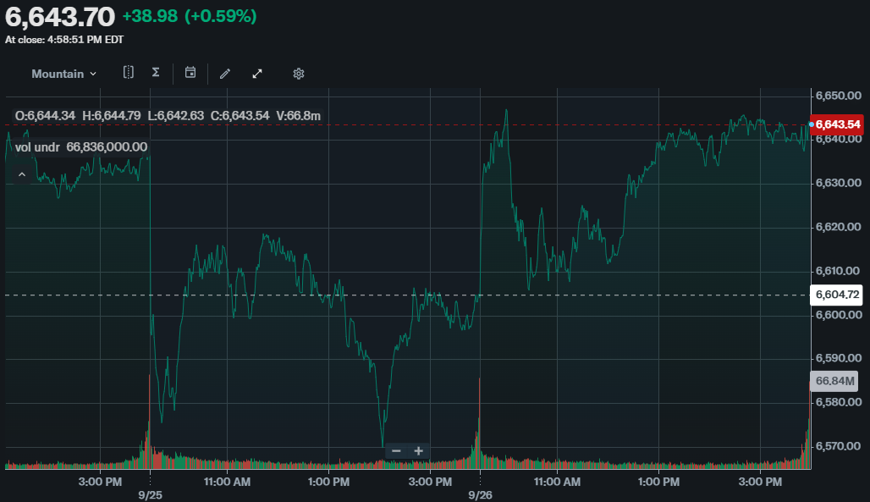
- https://finance.yahoo.com/

- https://www.bloomberg.com/
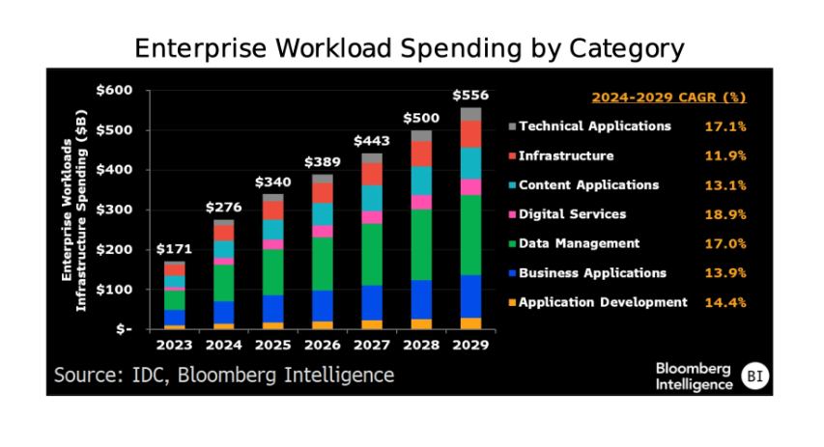

- https://ourworldindata.org/co2-emissions

